**IT enabled platform for Road Freight Transport**

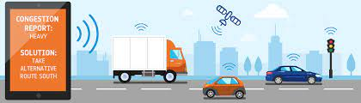

**Problem Statement:**

Road Freight Transport industry in India has emerged as important part in overall supply chain. Road freight operations in India are quite unorganized.

Small businesses struggle to serve the demand in efficient and optimal way. Customers also find it challenging to fulfil their need economically in time and safely. In India Road Freight Transport automation of processes is still in the embryonic stage. Hence it has become essential to bring operators on single platform, provide them with aggregation of customer demand using innovations of information era and creatively deploying up-to-date technology

**Solution:**

IT enabled platform intend to aggregate supply of truck services and demand of enterprises & individuals for road freight transport & logistics.

**Technology**: Mobile App, Web Interface, Machine Learning, Cloud Hosting

**Actors**: customers, transporters, Drivers

**Functionality:**

* Load Demand and Truck Availability matching engine
* Optimised Trip Scheduling
* Demand Prediction
* Dynamic route planning
* Tracking
* Real time visibility of the vehicle
* Dashboard
* Driver Management - Driver Performance, Feedback, Ranking
* Reports
* Accident Report - Full History of Vehicle / Driver
* Delivery Intimation

**Current Market:** Some enterprises have launched digital services such as

* <https://trucksuvidha.com/>
* <https://www.trukky.com/>
* <https://truckguru.co.in/index.php>